RESOLUTION NO.__________

RE: CERTIFICATE OF APPROPRIATENESS UNDER THE
PROVISIONS OF THE ACT OF THE PENNSYLVANIA
LEGISLATURE 1961, JUNE 13, P.L. 282 (53
SECTION 8004) AND BETHLEHEM ORDINANCE NO.
3952 AS AMENDED.

The applicant proposes to construct roofing over existing deck at 229 E. Wall St.

NOW, THEREFORE, BE IT RESOLVED by the Council of the City of Bethlehem that a Certificate of Appropriateness is hereby granted for the proposal.

Sponsored by: (s)

(s)

ADOPTED BY COUNCIL THIS DAY OF

(s)
President of Council

ATTEST:

(s)
City Clerk

HISTORICAL & ARCHITECTURAL REVIEW BOARD

The applicant proposes to construct roofing over existing deck at 229 E. Wall St.

APPLICATION 2:

Robert Cornelius
229 E. Wall St.
Bethlehem, PA 18018

OWNER:

__________________________________________________________________________

The Board upon motion by Marsha Fritz and seconded by Phil Roeder adopted the proposal that City Council issue a Certificate of Appropriateness for the following:

- To construct a roof over the existing deck at the rear of the house.

2. The new roof slope will match the garage roof scope.

3. The roof will be shingled with three tab asphalt shingles to match the house.

4. The gable end triangle will be closed with horizontal lap siding to match the garage.

5. The motion was unanimously approved.

__________________________________________________________________________

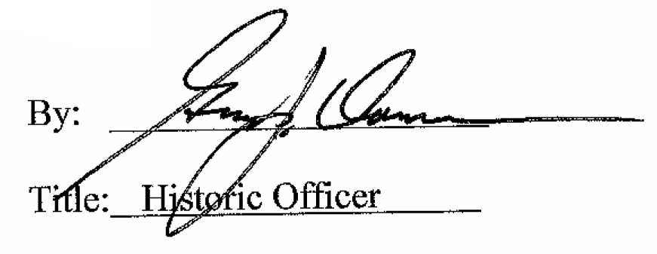

Date of Meeting: June 6, 2018

